6 How does OpenConnect help Netflix and other providers to cache content?

## Can you use this technique in your company?

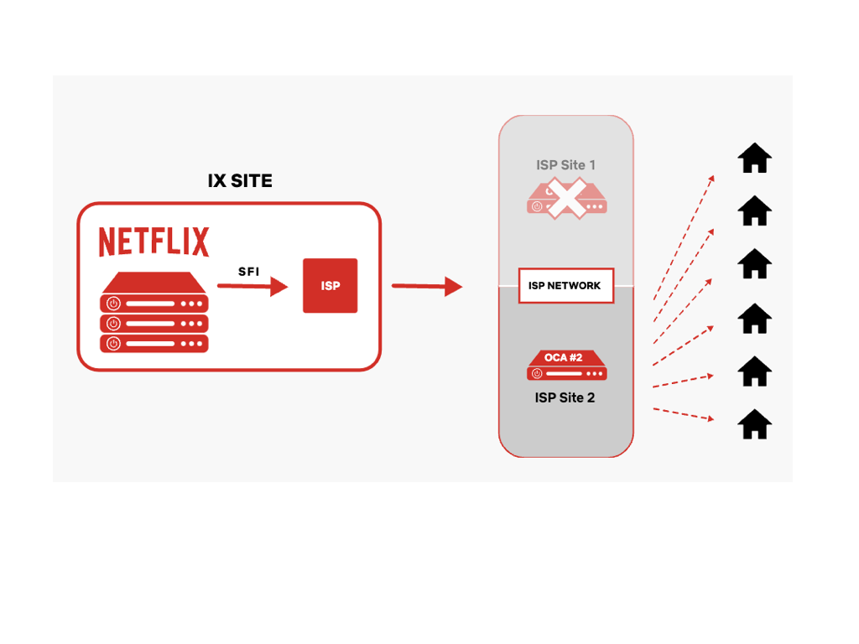

**https://openconnect.netflix.com/en/#sample-architectures**